1. Microcontroller Experiments using Arduino or MSP430:  
   Sensor based Experiments  
   a. Temperature and humidity Sensor.  
   b. HEART BEAT SENSOR.
2. **Tempaerature and humidity Sensor**

**Components Required:**

Arduino UNO – Read Best Arduino Starter Kits

DHT11 Temperature and Humidity Sensor

Breadboard

10k Ohm Resistor

Jumper Wires

**Pin Diagram:**

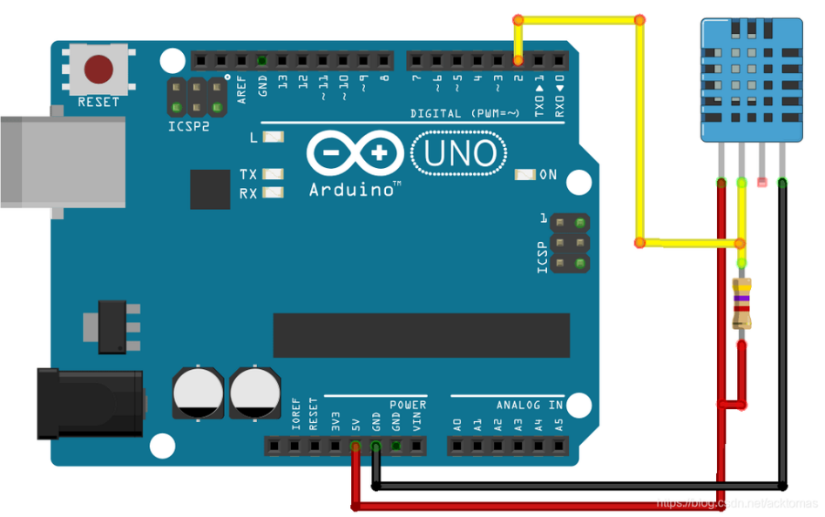

Program:

#include "DHT.h"

#define DHTPIN 2       // Pin connected to DATA

#define DHTTYPE DHT11  // or DHT22

DHT dht(DHTPIN, DHTTYPE);

void setup() {

**Serial**.begin(9600);

  dht.begin();

}

void loop() {

  float humidity = dht.readHumidity();

  float temperature = dht.readTemperature(); // Celsius

  if (isnan(humidity) || isnan(temperature)) {

**Serial**.println("Failed to read from DHT sensor!");

    return;

  }

  **Serial**.print("Humidity: ");

**Serial**.print(humidity);

**Serial**.print(" %\t");

**Serial**.print("Temperature: ");

**Serial**.print(temperature);

**Serial**.println(" *C");

  delay(2000);

}

Output:

1. Heart Beat Sensor

**Components Required:**

Heart Beat Sensor

Arduino UNO – Read Best Arduino Starter Kits

Breadboard

Jumper Wires

**Pin diagram:**

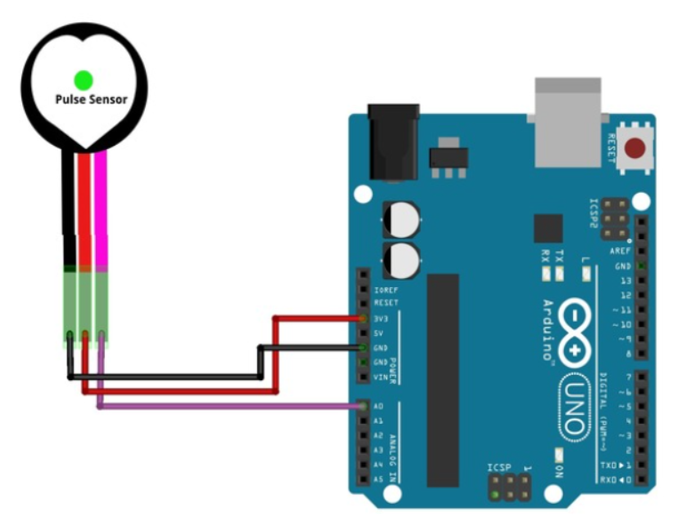

**Program**

#define USE_ARDUINO_INTERRUPTS true

// Include necessary libraries

#include <PulseSensorPlayground.h>

// Constants

const int PULSE_SENSOR_PIN = 0; // Analog PIN where the PulseSensor is connected

const int LED_PIN = 13; // On-board LED PIN

const int THRESHOLD = 550; // Threshold for detecting a heartbeat

// Create PulseSensorPlayground object

PulseSensorPlayground pulseSensor;

void setup()

{

// Initialize Serial Monitor

Serial.begin(9600);

// Configure PulseSensor

pulseSensor.analogInput(PULSE_SENSOR_PIN);

pulseSensor.blinkOnPulse(LED_PIN);

pulseSensor.setThreshold(THRESHOLD);

// Check if PulseSensor is initialized

if (pulseSensor.begin())

{

Serial.println("PulseSensor object created successfully!");

}

}

void loop()

{

// Get the current Beats Per Minute (BPM)

int currentBPM = pulseSensor.getBeatsPerMinute();

// Check if a heartbeat is detected

if (pulseSensor.sawStartOfBeat())

{

Serial.println("A HeartBeat Happened!");

Serial.print("BPM: ");

Serial.println(currentBPM);

}

// Add a small delay to reduce CPU usage

delay(20);

}

Output:

1. Microcontroller Experiments using Arduino or MSP430:
   1. Fire Sensor
   2. Big sound/small sound sensor
2. Fire Sensor

**Components Required:**

Arduino Uno

Breadboard

USB Cable

Sound Sensor Module

Buzzer (or small speaker)

Jumper Wires

**Program:**

const int fireSensorPin = 8;

void setup()

{

Serial.begin(9600);

pinMode(fireSensorPin, INPUT);

}

void loop()

{

int fireValue = digitalRead(fireSensorPin);

Serial.println(fireValue);

delay(500);

}

Pin Diagram

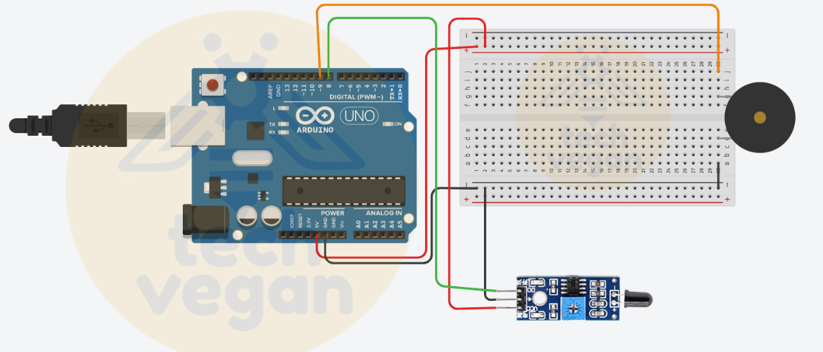

1. Big sound/small sound sensor

const int soundSensorPin = A0; // Analog pin connected to the Big Sound Sensor Module

const int ledPin = 2; // Digital pin connected to the LED (optional)

void setup() {

pinMode(soundSensorPin, INPUT); // Set the Sound Sensor pin as INPUT

pinMode(ledPin, OUTPUT); // Set the LED pin as OUTPUT (optional)

Serial.begin(9600); // Initialize serial communication for debugging (optional)

}

void loop() {

int soundValue = analogRead(soundSensorPin); // Read the analog value from the Sound Sensor

// Display the sound sensor value on the Serial Monitor

Serial.print("Sound Level: ");

Serial.println(soundValue);

// Adjust the threshold value according to your environment

int threshold = 400;

if (soundValue > threshold) {

// Sound detected! Add your desired action here.

// For example, turn on the LED as a visual indication of sound detection.

digitalWrite(ledPin, HIGH);

} else {

// No sound detected, turn off the LED (optional)

digitalWrite(ledPin, LOW);

}

delay(100); // Add a small delay to avoid rapid repeated detections

}